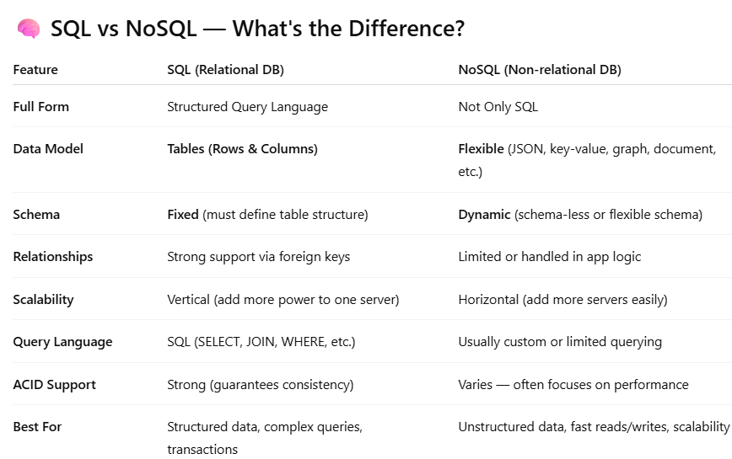

Why and When to Use MongoDB Instead of MySQL?
MongoDB is chosen over MySQL when you need flexibility, faster development, and scalability especially with unstructured or evolving data.
Why I Might Choose MongoDB Over MySQL:
1. Flexible Schema = Fast Iteration
- In MongoDB, I can store any shape of data, anytime
2. Great for Nested Data
- MongoDB supports deeply nested documents — perfect for:
  - Storing comments
  - Orders with line items
  - Chat messages
3. Faster for Reads/Writes at Scale
- MongoDB can handle massive volumes of real-time data (e.g., logs, analytics) with high write speed.
- It’s commonly used in modern web apps, mobile backends, and IoT.
4. Easy to Use with JavaScript/Node.js
- MongoDB uses JSON-like syntax.
- Perfect match with MERN stack (MongoDB, Express, React, Node).

What is a Hybrid Database System?
A hybrid system uses SQL for structured data and NoSQL for flexible or high-speed data — combining the best of both worlds.
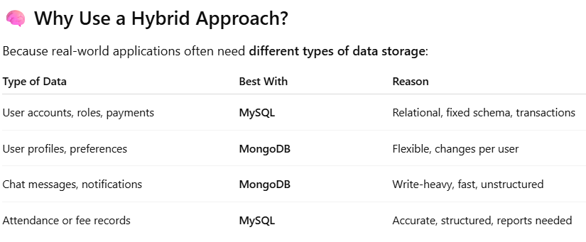

ACID = Atomicity, Consistency, Isolation, Durability
1. Atomicity
All or nothing. A transaction must completely succeed or completely fail — no in-between.
- If any part of the transaction fails, the entire thing is rolled back.
- Prevents partial updates.
2. Consistency
The database must move from one valid state to another, respecting rules, constraints, and relationships.
- Foreign keys, uniqueness, data types, etc. must always hold true.
- No transaction can leave the DB in an invalid state.
Example:
If a table requires marks to be between 0–100, inserting 200 would break consistency — and should fail.
3. Isolation
Concurrent transactions must not interfere with each other.
- Changes made in one transaction are not visible to others until committed.
- Prevents issues like dirty reads, non-repeatable reads, and phantom reads.
Example:
If two users try to update the same record at the same time, isolation ensures they don’t corrupt it.
There are isolation levels:
- READ UNCOMMITTED
- READ COMMITTED
- REPEATABLE READ (default in MySQL)
- SERIALIZABLE (strongest)
4. Durability
Once a transaction is committed, it is permanently saved — even if power fails right after.
- The data is written to disk/storage safely.
- Relies on write-ahead logging, journals, or redo logs.
Example:
After a payment is confirmed, even a server crash won’t erase it.
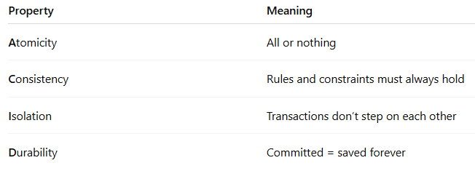

What is a schema
A schema is basically the blueprint or structure of your database — like the architecture plan for how your data is organized, related, and stored.

Why I Chose MongoDB Over MySQL:
I chose MongoDB over MySQL because my application required deeply nested data structures — like arrays inside documents, sub-documents, and dynamic schemas.
In MySQL, modeling such nested data would have required creating multiple relational tables, foreign keys, and complex joins, which would increase development time and reduce flexibility.
MongoDB, being a NoSQL document-oriented database, allowed me to store related information in a single document using JSON-like objects, making it easier to manage and query hierarchical data."

